GitHub:

Execution Steps (Windows):

1. Please Run the “TacoLocoApi.jar” in the “..\target” folder.
   1. It should open port 8080 as ‘localhost’ in the PC.
   2. As a standalone Spring Boot application, it will start the API service.
2. To place orders of Taco, you need Postman (or similar) REST environment.
3. There are two URL map for this project.
   1. localhost:8080/item/details
      1. Please run the URL in postman first. (Otherwise you may get HTTP:500 error, as there is a singleton object created to generate the Taco Menu)
      2. This will be a GET method request and response will be a JSON object list containing the names of the items and their unit prices.
   2. localhost:8080/item/entry
      1. This will the input request for the Taco Order [JSON format is provided below].
      2. This is a POST method request and response will be the name, quantity and individual cost of each item, following with the total amount of purchase and total cost calculation.

JSON Data Format:

* itemName: String,
* itemQuantity: Integer

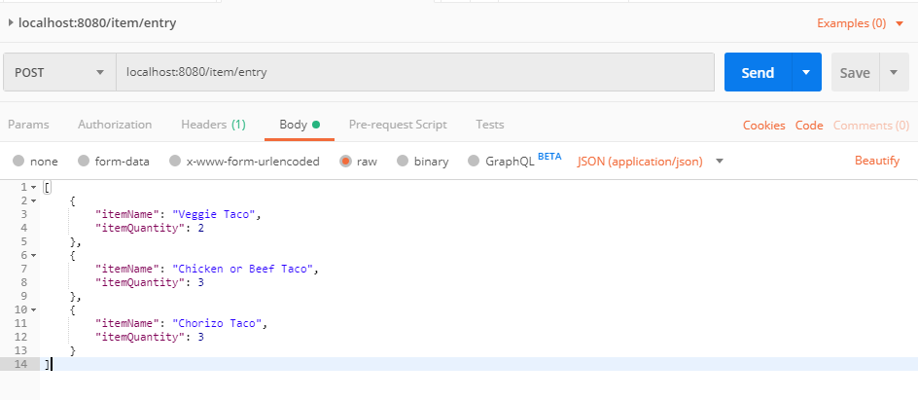

* Select POST method in Postman
* Select “raw” in the Body tab
* For better view select JSON (application/json) mode in the options.
* Output response can be seen by clicking “Send” button.

Sample Request: (localhost:8080/item/entry)

[

{

"itemName": "Veggie Taco",

"itemQuantity": 2

},

{

"itemName": "Chicken or Beef Taco",

"itemQuantity": 3

},

{

"itemName": "Chorizo Taco",

"itemQuantity": 3

}

]

**N.B:** If the 8080 port is still open after the execution of the API, please follow the steps below:

* Run command-line as an Administrator
* Write the command: netstat -ano | findstr :8080
* Note the PID as ‘LISTENING’ by the port
* Write the command: taskkill /PID <PID FOUND> /F

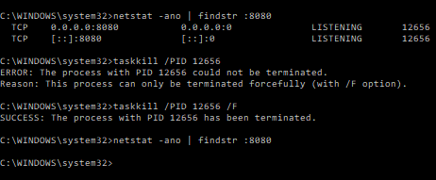

For details: <https://stackoverflow.com/questions/39632667/how-to-kill-the-process-currently-using-a-port-on-localhost-in-windows>

Problem Description:

Taco Loco, a quick service fleet of taco trucks, is building a new mobile app to enable their customers to place orders for their delicious tacos. They’ve hired you to build the backend services to power this app.

As a backend developer, you’ve been tasked with creating a web service to calculate order totals. The service will take as input the items and quantities ordered, and respond with the order total.

Taco Loco’s menu consists of the following items:

* Veggie Taco, $2.50 ea.
* Chicken or Beef Taco, $3.00 ea.
* Chorizo Taco, $3.50 ea.

If a customer orders 4 or more tacos, then a 20% discount should be applied to the entire order.

Taco Loco wants you to define the data format for the request and response, and prefers using JSON.